**Assignment 7**

**Problem Statement:** Object detection using YOLO and Pretrained Model.

**Library:**

* **Ultralytics**: For using YOLOv5 or YOLOv8 pretrained models.
* **NumPy**: For efficient numerical computations.
* **OpenCV**: For loading images and video streams, and handling basic image operations.
* **Matplotlib**: For visualizing images and detection results.
* **PyTorch**: Underlying deep learning framework for YOLO.

**Theory:**

YOLO is a single-stage object detection algorithm that divides the image into grids and directly predicts bounding boxes and class probabilities for each grid cell. Unlike other object detection systems (like R-CNN), YOLO performs object detection in a single forward pass through the network, making it incredibly fast.

* **YOLO Architecture**:

In YOLO, object detection is treated as a regression problem, where the neural network predicts a set of bounding boxes, confidence scores (indicating the likelihood of the object being present in the box), and class probabilities for each detected object. Each grid cell is responsible for predicting the objects that fall within it, with the network outputting multiple bounding boxes per cell. This results in a streamlined approach to object detection, enabling real-time applications such as autonomous driving, video surveillance, and robotics.

YOLO uses convolutional layers to extract high-level features from the image, with the final output layer responsible for producing the bounding box coordinates, objectness score, and class predictions. YOLO’s design ensures that both spatial information and classification are considered in a single architecture, reducing the need for complex post-processing steps.

**Pretrained Model**: YOLO models are pretrained on large datasets like COCO, which allow them to detect a variety of object classes (e.g., cars, people, animals). Pretrained models can be fine-tuned on new data for specific applications or used out-of-the-box for general object detection tasks.

**Methodology:**

1. **Install Required Libraries**: Install the ultralytics package to access YOLO models and tools.

!pip install ultralytics

1. **Load Pretrained YOLO Model**: Load the YOLOv5 or YOLOv8 pretrained model from the Ultralytics library.

from ultralytics import YOLO

model = YOLO('yolov8n.pt') # Load pretrained model

1. **Load and Preprocess Image**: Use OpenCV to read and preprocess the input image.

img = cv2.imread('image.jpg') # Load image

1. **Perform Object Detection**: Run the object detection model on the input image.

results = model.predict(img) # Perform object detection

1. **Visualize Results**: Use OpenCV or Matplotlib to visualize the detected objects with bounding boxes and labels.

results.show() # Show detection results

1. **Evaluate Model**: The model's performance can be evaluated using metrics like precision, recall, and mean Average Precision (mAP), based on the quality of object detection.

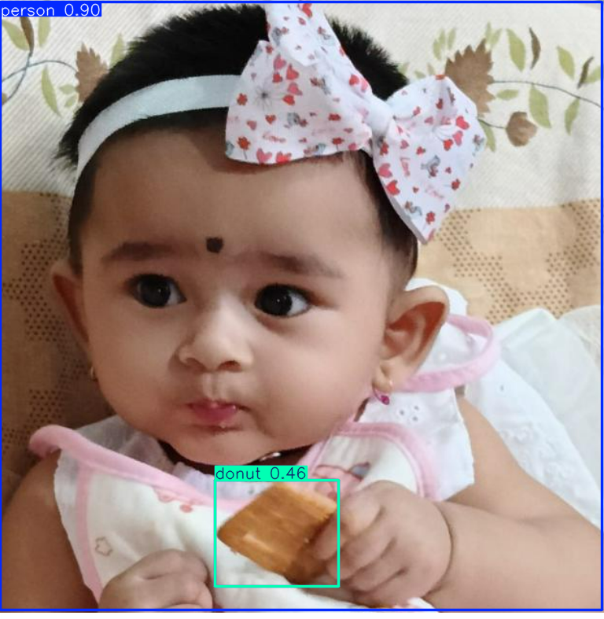

**Advantages:**

* **Real-Time Detection**: YOLO is one of the fastest object detection algorithms, capable of processing video streams in real-time.
* **High Accuracy**: Despite its speed, YOLO achieves competitive accuracy with fewer false positives due to its unique grid-based prediction approach.
* **Single Forward Pass**: YOLO's single-stage detection architecture makes it computationally efficient compared to multi-stage methods (e.g., R-CNN).

**Disadvantages:**

* **Small Object Detection**: YOLO may struggle with detecting smaller objects, as the grid-based detection system might not be fine enough for very small objects in the image.
* **Fixed Grid Size**: The use of fixed grid sizes can lead to inaccuracies in detecting objects that span multiple grid cells or objects that are positioned at the grid boundaries.
* **Lack of Detailed Localization**: YOLO's speed sometimes comes at the cost of more detailed localization of objects, which may be more refined in methods like Faster R-CNN.

**Conclusion:**

Using YOLO for object detection provides a powerful balance between speed and accuracy, making it suitable for real-time applications like surveillance, autonomous driving, and robotics. The use of pretrained models accelerates deployment by leveraging pre-learned object features from large datasets. However, careful consideration must be given to situations where small object detection is critical, as YOLO may underperform in such cases. Fine-tuning and dataset-specific adjustments can further improve the model’s effectiveness for specialized tasks. ​